

OPERATING MANUAL

TYPE MCP 4/06
UNIT 8 - WHITEBRIDGE INDUSTRIAL ESTATE
STONE
STAFFORDSHIRE ST15 8LQ
ENGLAND
TEL: +44 (0) 1785 815651
FAX: +44 (0) 1785 812115

MCP EQUIPMENT
UNIT 8, WHITEBRIDGE INDUSTRIAL ESTATE - STONE - STAFFORDSHIRE ST15 8LG
ENGLAND
TEL. (+44) 01785 815651 - FAX. (+44) 01785 812115
Email: equipment@mcp-group.co.uk - Web:

A DIVISION OF MINING & CHEMICAL PRODUCTS LTD.

Thank you for choosing an MCP Vacuum Casting Machine.

The Type 4/06 is a dual chamber model, the vacuum chambers themselves being of stainless steel and powder coated mild steel for long life and ease of maintenance. As well as being used for the actual casting process, the machine may be used for degassing both the silicone rubber mixture from which moulds are formed, and the two component MCP resins used in the finished products. In dual use, the chambers are sealed from each other by two plates. These plates can be raised forming one compartment for the purpose of making larger castings.

The equipment is controlled by two programmable logic controller units (one for each chamber), which drive the resin mixing and pouring mechanisms as well as controlling the vacuum pumping and pressure release. The process can be visually monitored through four large inspection ports or, when necessary, by means of internal cameras with colour video display mounted on the machine.

Please follow carefully the instructions for installation and use that are to be found in this Operating Manual, which also covers routine checks and adjustments. A separate SERVICE MANUAL is provided to deal with specific repairs, faultfinding and replacements which the manufacturer considers may be correctly and safely carried out by the user.

A further Manual, VACUUM CASTING TECHNIQUE, gives an overview of the system. A copy is supplied with every machine.

HEALTH AND SAFETY

All units supplied on or after 1st January 1995, bear the CE mark. The Declaration of Conformity will be found at the end of this Manual.

ELECTRICAL SAFETY
Certain of the tasks described in this manual require access to the electrical control enclosure, and should therefore be carried out only by a suitably qualified person.

MATERIALS SAFETY DATA
Though no special hazard is likely when they are used in accordance with the suppliers’ recommendations, each of the materials used in the process is the subject of a Safety Data Sheet, supplied at the time of first purchase and giving information in conformity with both European Directive 91/155/EEC and (in the United Kingdom) the Consumer Protection Act 1987.

NOISE
The equivalent continuous A-weighted sound-pressure level during working of this machine does not exceed 80dB(A).
CONTENTS

Page

INSTALLATION 8
Weight and dimensions
Power requirements
Siting the machine
Installation sequence
Pre-Operating Checks 9

SAFE WORKING PRACTICE 10

SELECTING 4/04 OR 4/06 MODES 12

PREPARATION FOR CASTING 13
Preparing the mould and flow-system
Preparing the resin
Fitting the cups and paddle

WORKING PROCEDURES 14
To make the machine ready for use
Operating modes / Control Panel Touch Screen Functions
Operating in manual mode
Using the automatic operating sequence
Stopping in emergency
Re-starting after emergency 15
Shutting down

CONTROL PANEL TOUCH SCREEN FUNCTIONS 16
Manual functions
Auto functions

APPENDIX 25

ROUTINE MAINTENANCE PROCEDURES 28

DECLARATION OF CONFORMITY 29

Illustrations

Fig. 1 General front view 3
Fig. 2 Control Section Front Access Door 4
Fig. 3 Inner Door Control Panel at Rear 5
Fig. 4 Vacuum Pump Access (at each side of machine) 5
Fig. 8, 9, 10 Operating Inner Door Controls 12

Standard accessories: Illustrations and Part Numbers 6-7
VACUUM CASTING MACHINE

TYPE MCP 4/06

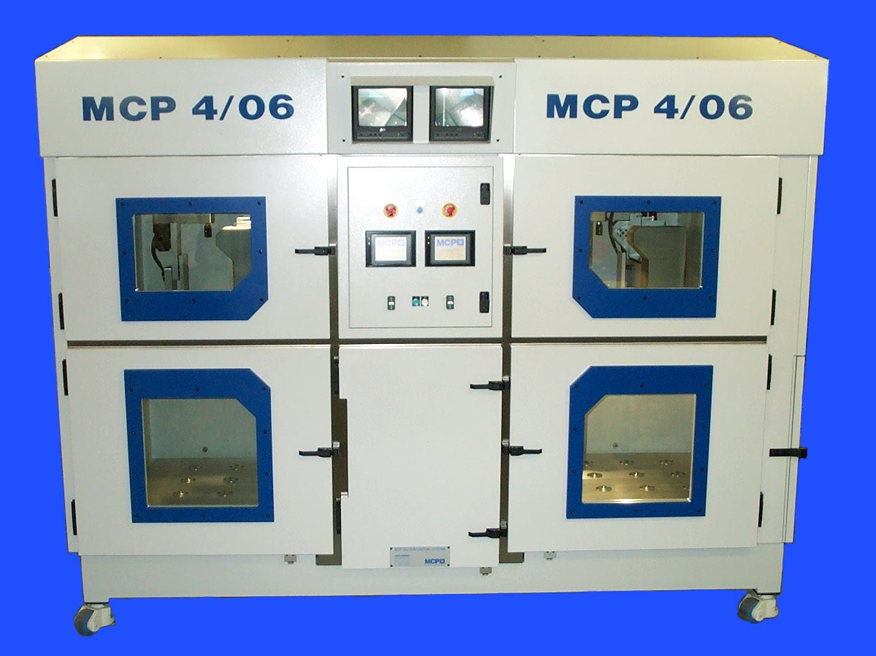

Fig. 1 General front view

VACUUM CASTING MACHINE

TYPE MCP 4/06

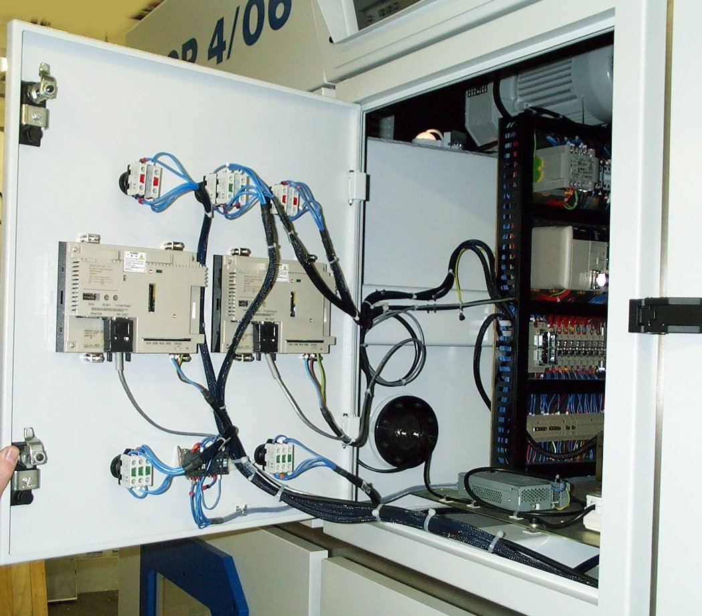

Fig. 2 Control Section Front Access Door

VACUUM CASTING MACHINE

TYPE MCP 4/06

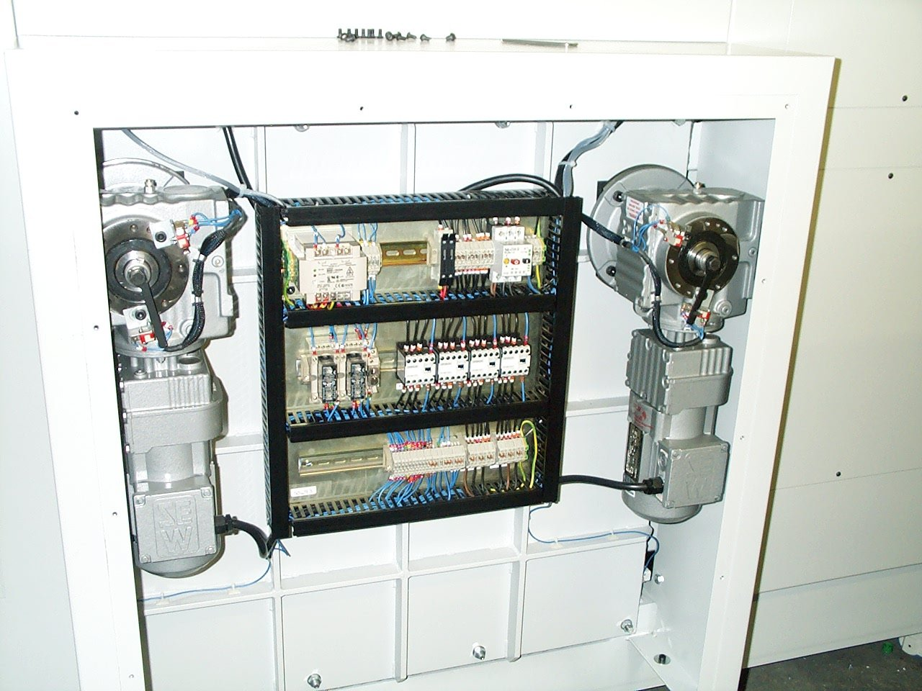

Fig. 3 Inner Door Control Panel at Rear
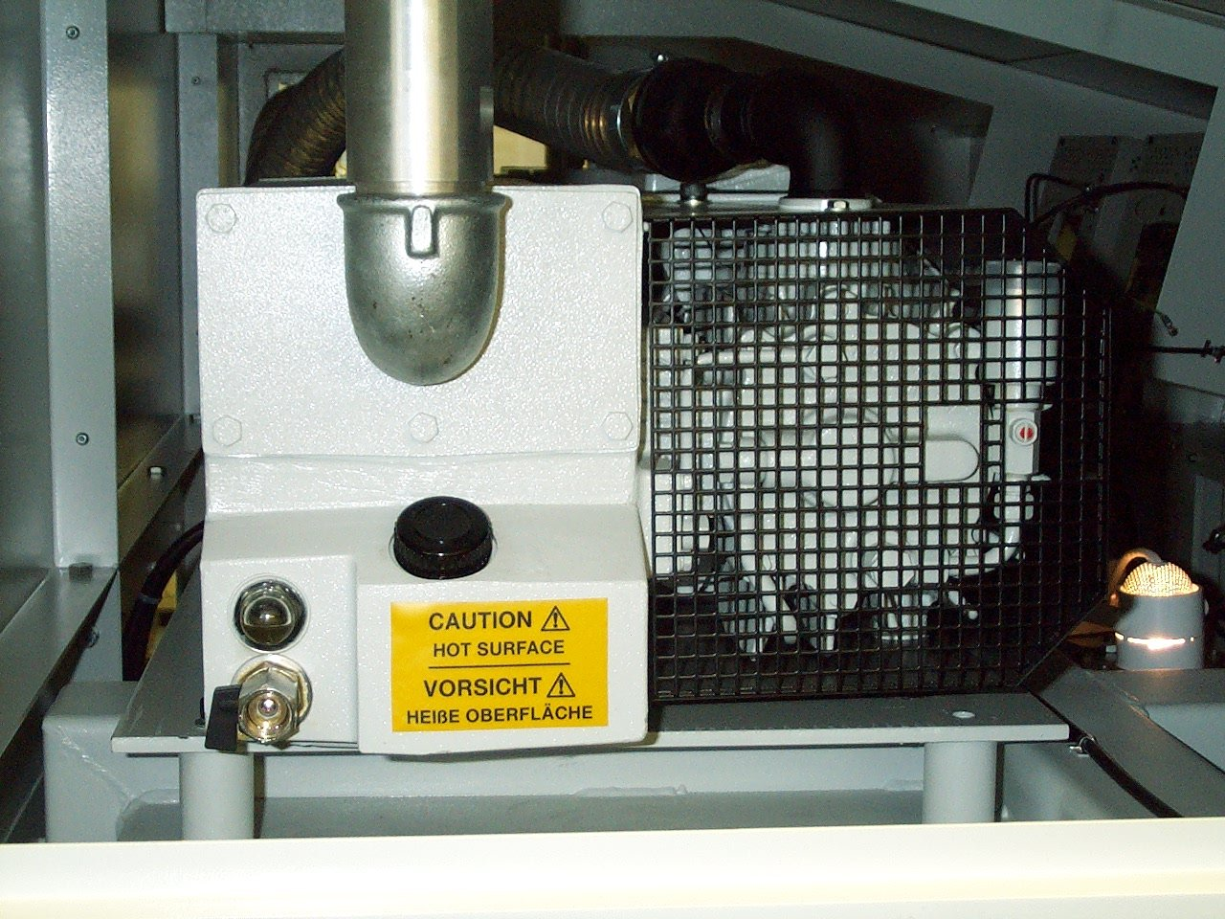

Fig. 4 Vacuum Pump Access (at each side of the Machine)

STANDARD ACCESSORIES RANGE

( NOT AVAILABLE FOR MCP 4/06)

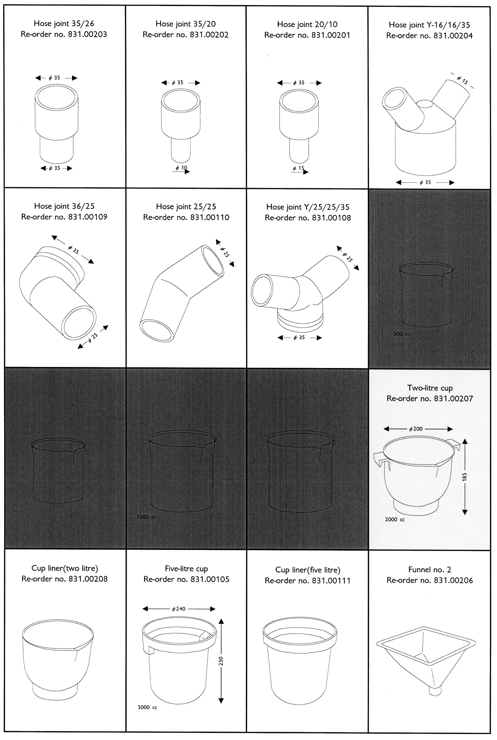

STANDARD ACCESSORIES RANGE

( NOT AVAILABLE FOR MCP 4/06)

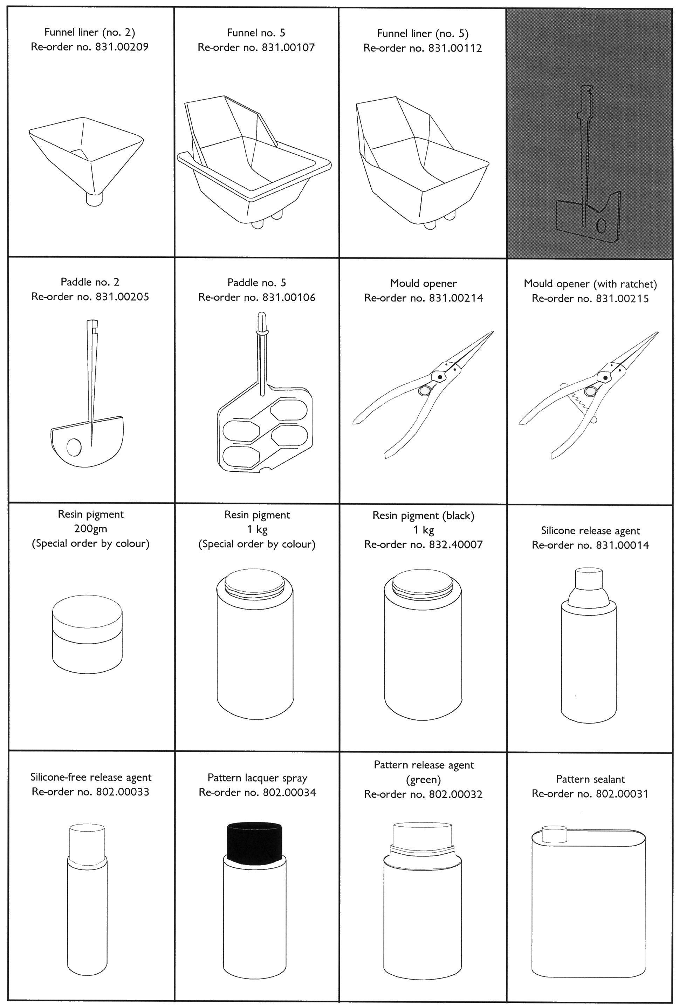

INSTALLATION

WEIGHT & DIMENSIONS

* Weight: Nett weight 4000kg Shipping weight: 4200kg
External dimensions (mm): 2550 high x 1510 wide x 900 front-to-back.

POWER REQUIREMENTS

* The unit requires a three-phase, 415 volt supply, with switch capacity 32 amp and an overload breaker rated for 40 amp.

* An earthing point and a circuit-breaker must be provided.

SITING THE MACHINE

* Do not site the unit in an area subject to excessive heat or high humidity.

* Choose a well-ventilated area. If possible, provide local exhaust ventilation to an outside vent.

* Avoid areas exposed to dust or vibration.

* Ensure that the unit is level, and that the feet are locked.

* For ease of access in servicing, you are recommended to leave a clear space of at least one metre to the rear of the machine and at least two metres at the front and sides. Side clearance in needed to allow the floor plates to be fitted or removed.

INSTALLATION SEQUENCES

Installation is divided into two phases. Physically locating the machine and connecting it to the electrical supply is followed by a series of tests and the set-up procedures necessary to ensure correct operation.

Before beginning installation, please read through the instructions and ensure that you can identify each of the parts referred to.

Electrical connections should be made only by an appropriately qualified person.

INSTALLATION Continued.

PRE-OPERATING CHECKS
NB: if any of the following cheeks should fail, consult the manufacturer immediately.

- Open the front upper panel of the pump unit to reveal the electrical supply components. Identify the 'PHASE FAILURE DETECT' components WZMA and WZM-2 (see fig. 3): each has a red button, both of which should now be pressed to switch the unit off. Close the panel.

- Switch on the power at the main isolator at the top left front of the pump unit. Turn the adjacent key-switch to the released position and press the green RE-SET button. Both video display screens should now be operational and both vacuum chambers should be illuminated. If all chamber lights are out, check that the voltage between each phase and neutral is 240V; this appears across wires 65 and 66 on FU2/L1K2. If the voltage is correct, change the light-bulbs themselves.

- Activate the left-hand chamber by turning clockwise the orange-coloured rotary switch on its operating panel. Check that (a) the red indicator glows above the switch and (b) that the digit '1 * appears in the program display window of the control panel below.

Press the PROGRAM button on the control panel: the LED at its top left corner will light. and the program number will remain unchanged as '1*.

Press the UTIL-2 button on the control panel. The machine's accumulated operating time is displayed in the TIMER window: this is set to zero during assembly. The non-volatile value is able to accommodate 9.999 hours. The time displayed is that in actual operation, rather than the period of time during which the machine has merely been switched on.

- Repeat sequence 3, activating now the right-hand chamber.

- Press the black buttons of both 'PHASE FAILURE DETECT' components WZMA and WZM-2 to the ON position.

- Close the upper front panel of the pump unit and open the lower front.

- Close the doors of both vacuum chambers (four in all). Note: the main unit is supplied ready to operate in combined-chamber mode, i.e. with the lower centre panel in position and without the separator being in place.

Confirm the direction of rotation of the (upper) pump motor M1. Place a piece of thick card to mask the exhaust opening on top of the pump unit; press the MANUAL button on the left-hand control panel, when the pump should rotate in the direction marked by an arrow, discharging air blowing away the card. Switch off by pressing the button a second time.

* Caution: when confirming the pump rotation, operate for no more than 1-2 seconds.
Failure to make this check correctly may lead to oil entering the vacuum chamber.

The direction of rotation can be altered by changing over any two of the three live three-phase leads in the pump's individual supply cable. Before doing this, first turn the key switch to OFF on the pump unit, switch off at the isolator and disconnect power from the machine.

Confirm the correction if it is necessary to make a change.

- Repeat sequence 7, operating the control panel for the right-hand chamber to check the rotation of the (lower) pump motor M2.

SAFE WORKING PRACTICES

Users of equipment should satisfy themselves that they comply with the requirements of the relevant legislation within the United Kingdom (or equivalent regulations within the country of use).

Particular attention is drawn to the following:-

- Health and Safety at Work etc. Act 1974;
- Personal protective Equipment at Work Regulations 1992;
- Provision and Use of Work Equipment Regulations 1998;

Provision and Use of Work Equipment Regulations

In general terms, the Regulations require that equipment provided for use at work is:

- Suitable for the intended use;
- Safe for use, maintained in a safe condition and, in certain circumstances, inspected to ensure this remains the case;
- Used only by people who have received adequate information, instruction and training; and;
- Accompanied by suitable safety measures, e.g. protective devices, markings and warnings.

Personal Protective Equipment

Users should be aware of the requirements of the Personal Protective Equipment at Work Regulations 1992 when providing equipment.

The main requirements of the PPE at Work Regulations 1992 is that personal protective equipment is to be supplied and used at work wherever there are risks to health and safety that cannot be adequately controlled in other ways.

Because the effectiveness of PPE can easily be compromised, e.g. by not being worn properly, it should always be considered as a last resort and only used where other precautions cannot adequately reduce the risk of injury.

Even where engineering controls and safe systems of work have been applied, some hazards might remain. In considering methods of safeguarding machinery the use of personal protective equipment may be used to minimise the risk of injury. This includes the need for special clothing, including footwear, hearing, eye and respiratory protection.
The guidance shown below may be used to consider the risks which may or may not be present. The user should make his own assessment of risks depending upon the
circumstances of use.

SAFE WORKING PRACTICES CONTINUED

 | Hazards | Options
HANDS | Abrasion; Temperature extremes; cuts and punctures; impact; chemicals; skin irritation. | Gloves, gauntlets  Notes:  - Don’t wear gloves when operating machines where gloves might get caught.  - Care in selection is needed.

EYES | Chemical or metal splash; dust; projectiles. | Spectacles, goggles, visors.  Notes:  - Make sure the eye protection chosen has the right combination of protection for the task.
 | Chemical or metal splash; dust; projectiles.
FEET | Wet; slipping; falling objects; heavy loads; metal and chemical slash | Safety boots and shoes.  Notes:  - Consider conditions of use.

BODY | Heat; chemical or metal splash; spray from pressure leaks; impact; entanglement of own clothing. | Conventional or disposable overalls, aprons.  Notes:  - Consider choice of materials in relation to the chemicals involved.

RESPIRATORY | Dusts; gases and vapours. | Disposable respirators, half masks or full face masks, powered respirators.  Notes:  - The right type of respiratory must be used for the substance being handled.
 | Dusts; gases and vapours.
HEARING | Impact noise; intensities; pitch. | Ear plugs or defenders.  Notes:  - See Noise at Work Regulations 1989.
 | Impact noise; intensities; pitch.

NOTE: Use personal protective equipment only as a last resort. Wherever possible engineering controls and safe systems of work should be used instead. All those required to wear protective equipment should be given training in its proper use, care and maintenance.

SELECTING 4/04 OR 4/06 MODES
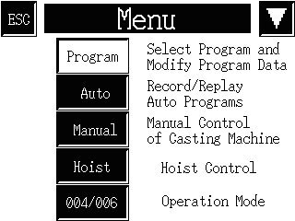
The machine can be operated in two main modes; 4/04 Mode where each chamber behaves independently from the other, or 4/06 Mode in which both chambers act as one, either with the chamber dividers in place or removed to allow for larger moulds and capacities.

Each mode is described in full below.

4/04 Mode

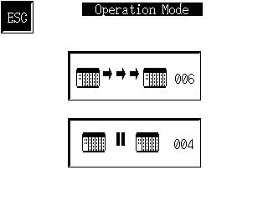
From the main menu screen (Fig. 5) select 004/006. This displays the screen shown in Fig. 6. From here, select the button marked 4/04. Once selected, the screen will display the opening title screen.
Fig. 5

The machine is in 4/04 Mode. Each chamber can now be operated fully independently from the other. Refer to the section “Working Procedures” on page 14.

4/06 Mode

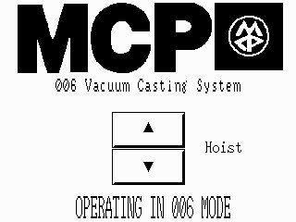
The user must first decide which side will be the Master unit, as this will become the screen from which all operations will be controlled. Once again, from the main menu page, select the MODE button. When the selection screen is displayed, press the button marked 4/06. This will be confirmed by on Slave screen by displaying a confirmation screen shown in Fig. 7. The Master screen will then display the main title screen.
Fig. 6

Once 4/06 Mode has been selected the Slave chamber will mimic all the actions of the Master chamber.

Once the machine has been put into 4/06 Mode, the user has the option to open the chamber inner doors allowing the casting of larger moulds.

To open the inner doors;
Fig. 7
- Ensure that there is no vacuum within either chamber as this can cause an overload in the door opening control.
- Press and hold the ‘UP’ pushbutton mounted below the screens in the centre of the control section (Fig 8).
- When the pushbutton illuminates the doors are fully open.
- If required, the two hoists can be removed and replaced with the roller bed for each of the chamber sections (left, middle & right). These roller beds can be stored below the machine when not in use.

If the doors need to be lowered, reverse the above procedure, remembering to remove the roller beds to prevent damage.
Fig. 8
Fig. 9
Fig. 10
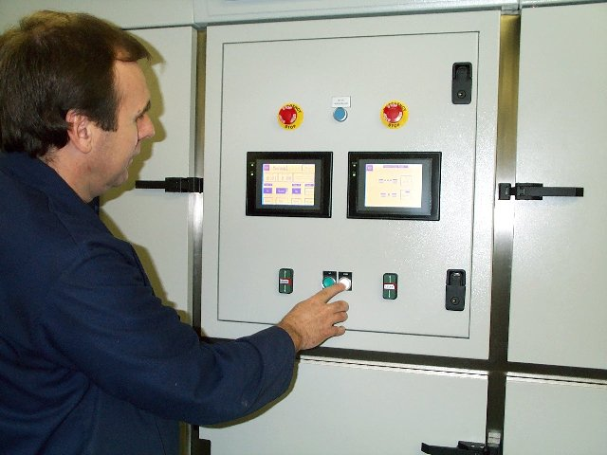
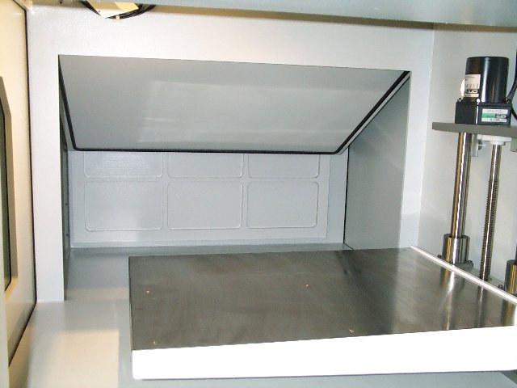
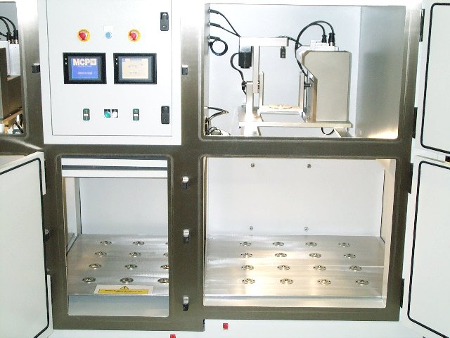
PREPARATION FOR CASTING – 4/04 MODE

The sequence of operations (explained in general terms in the companion Manual VACUUM CASTING TECHNIQUE) requires the resin component cups, the whisk for mixing, a funnel and hoses all to be put correctly into place above the entrance gate(s) to the mould.

PREPARING THE MOULD AND FLOW-SYSTEM

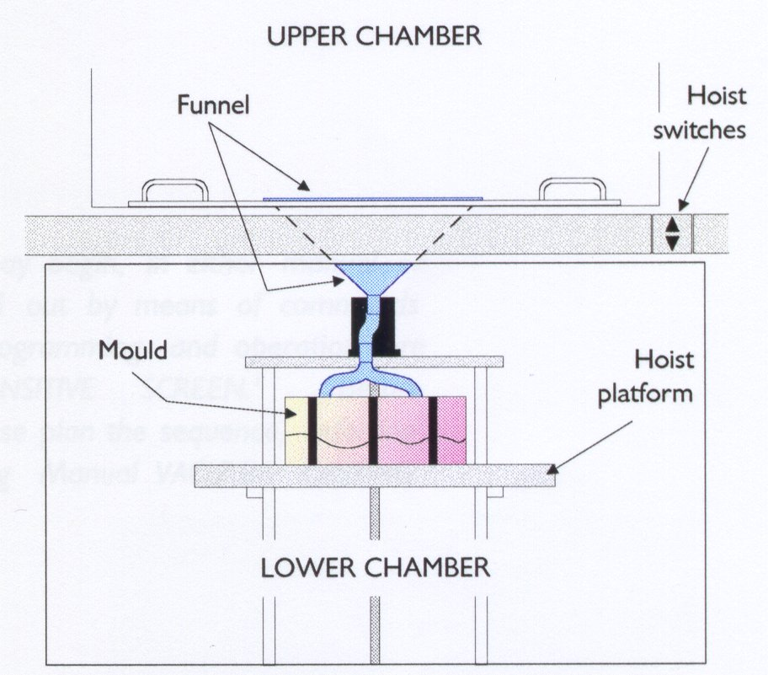
The standard accessory range includes several joints (see page 6), which may be employed in conjunction with clear plastic hose to direct the mixed resin into the mould, with the flow being spilt through Y-joints if need be.
Fig. 11 Arrangement of the mould and accessories

Fit the funnel (see fig. 11) into the centre of the carriage in the upper part of the chamber, locating the front edge over the guard plate on the funnel position, and place the prepared mould (on a support platform in necessary) in the lower chamber. NB – do not use any form of support that might inflate under vacuum.

Decide on the pattern and sizes of hose and any connectors that may be needed, keeping the runs as short as conveniently possible.

Prepare the hose outlets, fixing to both funnel and mould. Ensure that you obtain a good fit, but one that is not too tight. Leave no end open.

PREPARING THE RESIN

Two- or three - component resins should be prepared in accordance with the supplier’s instructions and placed in the appropriate cups.

Although casting may be carried out without them, it is recommended that cup liners be always used.

For general guidance, refer to the manual Vacuum Casting Technique: a guide for new users supplied with the machine.

FITTING THE CUPS AND PADDLE

Fit the cups into their cradles, ensuring always that component ‘A’ is in cup ‘A’ (the upper right cup).
- Place cup A in its cradle, engaging the spout with the V-shaped cut-out. Ensure that the lip of the cup (and that of it’s liner, if used) is beneath the lip of the retaining clip.
- Remove the paddle from its clip (above cup B).
- Pull open the retainer assembly (with V-shaped cut-out) for cup B. Slide the cup B into the cradle, ensuring that the lip of the cup (and that of it’s liner, if used) is beneath the lip of the retaining clips at the side and rear of the cradle. Close up the retainer place, keeping the spout of the cup in the V-shaped cut-out, and lock it by turning anti-clockwise the knob at its left.

Re-fit the paddle by sliding it into its holder, ensuring that it is fully engaged by the spring-loaded ball.

BEFORE BEGINNING A CASTING, ALWAYS HAVE READY THE
APPROPRIATE SOLVENT FOR CLEANING UP RESIDUAL RESIN.

WORKING PROCEDURES

- TO MAKE THE MACHINE READY FOR USE

Switch on the machine at the isolator.
Press the blue re-set button (the inside of the chamber is now illuminated).

The machine is now ready for use.

ALWAYS CHECK THAT BOTH RESIN COMPONENTS – AND THE MOULD – ARE IN POSITION BEFORE ATTEMPTING TO MIX AND CAST

- OPERATING MODES

The machine can be operated entirely in manual mode or auto mode (Fig. 13).

KEEP YOUR HANDS OUT OF THE VACUUM CHAMBER WHILE ANY OF THE MECHANISMS ARE OPERATING

- OPERATING IN MANUAL MODE

Select the manual screen.
Press ‘Pump’ to begin chamber evacuation.
Press ‘Speed’ to select the mixing speed.
Press ‘Run’ to start the mixing of part B.
Once the vacuum time has been achieved, stop the mixer.
Press ‘A’ cup down, allowed resin ‘A’ to drain into cup ‘B’
Press ‘A’ cup up.
Re-start the mixer.
When the mixing is complete, stop the mixer and tilt cup ‘B’ by pressing its DOWN button. Allow it to drain before pressing the UP button to return cup ‘B’ to up position.
When the pouring is complete and the resin has settled, press the SLOW LEAK button. The slow leak will start to force the resin further into the mould. This should be continued for up to 30 seconds, after which pressing the FAST LEAK button will release the remaining vacuum fully, forcing the resin completely into the mould.

- USING THE AUTOMATIC OPERATION SEQUENCE

With the mould, accessories and resin components all in place close the chamber doors.
Select required program
Go to AUTO REPLAY
Start the program.

- STOPPING IN AN EMERGENCY

To deal with unforeseen or unplanned steps in operation (for example, forgetting to load with a resin component, or an apparent malfunction as a result of faulty programming):
Operate the red STOP button (it will lock into place)
The machine is now completely shut down: nothing with operate.

WORKING PROCEDURES continued

- RE-STARTING AFTER EMERGENCY

Rotate and release the red STOP button
Press the blue re-set button
Press ‘Esc’ to return to the main screen.

The machine can now be operated again. Gain access to the chamber after first operating the FAST LEAK control to release the vacuum. It will then be possible to correct any fault before continuing.

- SHUTTING DOWN

Complete shutdown: turn off the power supply at the isolator switch.

AFTER CASTING – A REMINDER
Remove the cups and liners, the funnel and the pipes as soon as possible and clean them out with the recommended solvent, ready for re-use.

WORKING PROCEDURES continued


CONTROL PANEL TOUCH SCREEN FUNCTIONS
Title Screen
Fig. 12
The MCP type ‘PLC’ vacuum casting machines are controlled by a touch-sensitive screen, which first appears in the form of fig. 12. Please note that only the lightest of touches is required: do not press the screen unnecessarily hard.
Fig. 13

Touching the screen at any point of this display produces the menu screen of Fig. 13.

Menu Screen
Note: the ESC button at the top left corner recalls the display last show, while the ‘down’ arrow at the top right calls up the next screen in a sequence. These buttons have the same functions on whichever screen they appear.

Any of seven function screens – briefly introduced below, and described fully on the pages indicated – can be called up by touching the appropriate button on the Menu screen. The next four are on a separate screen, reached by touching the arrow button.

PROGRAM
Touching the Program button produces the Select program screen (page 18, Fig. 16), from which an existing program may be selected. The selected program may then be either operated or modified, as desired.

AUTO
Touching Auto invokes the Auto replay screen (page 21, Fig. 26), with its two alternatives. The first monitors a running program, while the second allows a program to be recorded and stored.

MANUAL
The Manual button leads to the Manual control screen, (page 23, Fig. 36), from which the operator has step-by-step control.
WORKING PROCEDURES continued

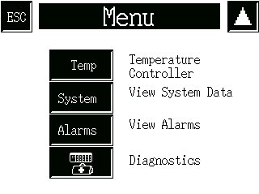
Functions available from Menu screen (continued)
Fig. 14

The second screen, reached by touching the arrow button at the top right corner, is shown in Fig. 14

TEMP

Access to the temperature control screen for cup ‘B’ is possible only when the option is actually fitted (see Appendix, page 23). If the option is not fitted, the screen in Fig. 15 appears when the Temp button is selected.
Fig. 15

SYSTEM
The System data screen (page 24, Fig. 37) displays information about running times of the machine and the mixing speeds (which can be altered at the screen) currently programmed.

ALARMS
The Active alarms screen (page 24, Fig. 38) shows any current alarm operation. Records of previous alarm operations are also available from the screen.

DIAGNOSTICS
The Diagnostics screen shows the actual PLC input and output states. This is only used to assist with any system fault diagnosis. A battery health lamp warns of the PLC lithium battery condition. If the PLC detects that the internal backup battery has failed the lamp will clear.

WORKING PROCEDURES continued

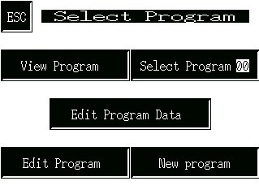
THE PROGRAM SELECTION SCREEN
Fig. 16

Touching Program on the Menu screen invokes the screen shown in Fig. 16, from which one of five alternatives may be chosen (apart from Menu, which returns control to the menu screen)

No program can be run from this screen, or any of its subsidiaries: control must first be returned to the Menu Screen.

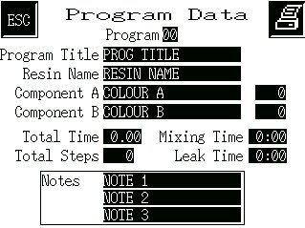
Fig. 17

VIEW PROGRAM
The View program option displays the Program data screen of Fig. 17.

This is simply a display of the currently selected program, not modifiable from this screen. The Select program screen can be regained by touching ESC.

Fig. 18

SELECT PROGRAM 00
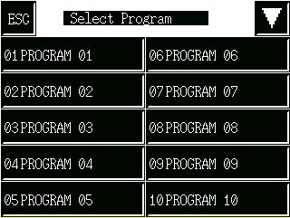
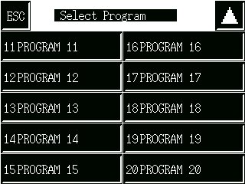
The Select program option (Fig. 18) displays the programs that are stored and currently available.
Fig. 2

Touching the arrow button at the top right toggles between similar screens, each with ten stored program options.

Select by touching the appropriate button. After indicating your choice, touch ESC (once or twice, as required) to return to the Select program screen, and again to display the Menu screen.

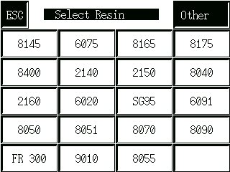
Fig. 19

EDIT PROGRAM DATA
The third choice from the Select program screen – available only when a program has already been selected – is Edit program data. The user is first asked to choose between UK and HEK resins. When the user makes the selection the screen on the right is displayed.

Twenty popular types of resin are shown on the screen (Fig. 19), any of which may be selected for substitution in the already-chosen program; in this case, a series of screens will appear to allow various modifications. When the resin to be used is not shown, the Other button will allow an alternative type to be used in the selected program.

WORKING PROCEDURES continued

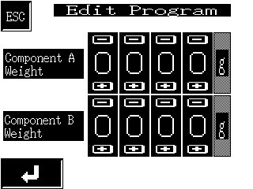
EDIT PROGRAM DATA – continued

STANDARD resin type

Selecting a standard resin type first produces the screen of Fig. 20, on which the intended weight of the resin casting is entered by means of the and buttons.

The weight may be registered by touching the return button at the bottom right corner, after which the screen of Fig. 21 appears.

Each screen that follows in this sequence has an up and a down arrow key to (respectively) return to the previous screen or to proceed to the next.
Fig. 20

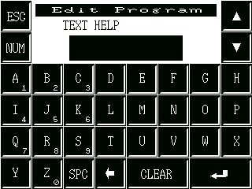
The current title of the program already selected appears (always in capital letters) on the bar above the keys, and it can be edited if necessary.

Touching Clear will remove the existing title, which may then be replaced. Single characters may be removed by the backspace key. The Num key toggles the number pad on and off, highlighting the numbers on a red background when it is operative, allowing numbers to be included at will. SPC gives a space marked by an underline.

The program components are selected by means of the down arrow button, and appear in the following order below the Program bar:
Fig. 21

Colour of component ‘A’
Colour of component ‘B’ (as required)

Notes – 1, 2 and 3 (as required)

The complete description suite is finally registered by touching the ‘carriage return’ key at the bottom right corner to show the screen of Fig. 21. Either choice will return the display to the Select program screen (Fig. 16). The entries will appear thereafter on the Program data screen (Fig. 17) whenever it is invoked for the particular program.

‘OTHER’ resin type

Fig. 22

When a resin is to be used that does not appear on the standard list, touching the Other button produces the Edit program data screen of Fig. 20. Here, the actual weights to be used of each separate component must be entered (remembering always to identify component ‘B’ with cup ‘B’ in the casting machine).

The carriage return button moves control to the Edit program screen (Fig. 20), from where the procedure may be continued. After an initial screen on which the resin name must be entered, procedure is the same as for a standard resin type.

WORKING PROCEDURES continued

EDIT PROGRAM
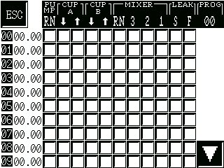
WARNING – the purpose of the Edit program facility is to display steps in a program already registered. The displayed program may also be edited, but only an experienced operator should undertake such a task.
The fourth choice from Select program displays the screen of Fig. 23. The left-hand column displays the step numbers of the selected program from 00 to 09 : four further, similar screens display subsequent steps, also in batches of ten, up to no. 49 (the maximum for a program is 50 steps, including 00). The arrow button at the bottom right corner changes to the next display : intermediate screens have two button, for forward and backward movement.
Fig. 23

The buttons in the main body of the display have an on/off toggle action, a blacked out button indicating that a function is active as the step commences. The explanation of the eleven abbreviated column headings is as follows:

PU CUP CUP MIXER LEAK

MP A B

RN ⇓ ⇑ ⇓ ⇑ RN 3 2 1 S F

Pump switch Cup movements Mixer switch: Slow Fast (up/down) On Fast Med. Slow Leak Leak

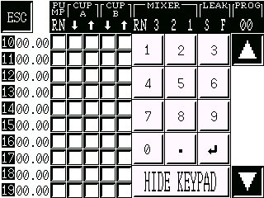

The second column across the screen displays the program time, which must elapse before the step occurs. The time may be altered by touching it on the screen, which changes the display to that of Fig. 24 (where a number pad has been superimposed by touching the 00.00 adjacent to step 14). The time is accepted by touching the return button, after which further times may be adjusted, or the keypad display hidden. WARNING: subsequent times are not altered automatically and must, when necessary, be changed manually.

Fig. 24

When all entries are completed, the ESC button on the current display shows the screen of Fig. 25, where the changes may be confirmed by the Yes button, or rejected by the No button. Either choice returns control to the Select program screen (Fig. 16).

Fig.25

WORKING PROCEDURES continued

NEW PROGRAM

The final choice from the Select program screen is New program, which is used to install functions with a resin already selected and for which the component weights are already specified.

The program name and number should already have been selected. The first display to appear (Fig. 26) requires the length of the first period of mixing to be entered (the default is one minute).

Fig. 26

When the time has been correctly entered, it may be registered by means of the carriage return button, which reveals the display of Fig. 27, on which the rotation speed of the mixer must be specified. The default speed for the mixer is 1 (low speed).

After selecting the preferred option (the button turning from white to black), it may be confirmed by means of the carriage return button, which displays a screen similar to that of Fig. 26, but requiring the second mixing period to be entered. Again, the default is one minute: if a second period is not needed, the time should be set to zero.

After confirming the second mixing period by touching the carriage return, a fourth display, similar to that of Fig. 27, appears for entry to be made of the mixer speed.
Fig. 27

When the second mix speed has been selected, the following screen asks for a Leak Time to be entered.

The carriage return on this fifth display brings up the screen of Fig. 28, where the changes may be confirmed by the Yes button, or rejected by the No button. Either choice returns control to the Select program screen (Fig. 16).

Fig. 28

AUTO RECORD AND REPLAY

On touching the Auto button at the Menu screen, the Auto replay screen (Fig. 29) appears, displaying the name of the program already selected.

The program may be run as it stands, or it may be replaced by recording over it. The latter option is not a modification, but requires a complete new sequence to be entered.

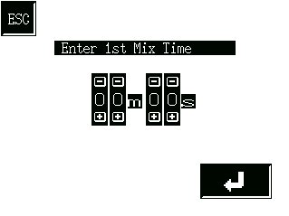
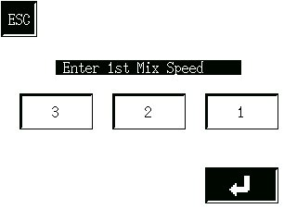
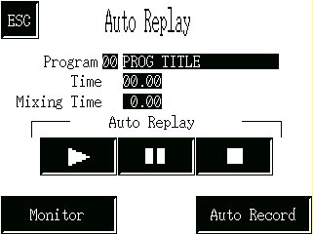
Two buttons – the ‘Play’ and Auto record – flash when the screen is opened.
One of the other of these options must be chosen before continuing.

Fig. 29

WORKING PROCEDURES continued

AUTO REPLAY

Three buttons control the automatic replaying of a selected program :

 the ‘play’ button begins the program immediately :

 the ‘pause’ button stops the program temporarily :

 the ‘stop’ button returns the program to the beginning.

Touching the Monitor button (Fig. 29, page 22) enables progress of the program to be followed.
Fig. 30
The full bar beneath Pump indicates progress during initial evacuation of the chamber, completion being shown by the OK button.

A lamp indicates an operation in progress. In the example shown, the pump is running, while the program time yet to elapse is 5 min. 23 sec. And the mixer has been running at medium speed for 31 sec. Note: the counter runs forward during recording, but backward during replay.

The end of the sequence (normally, when the vacuum has been completely released) is indicated by the appearance of the Auto replay display of Fig. 29 (page 22). The ESC button on this screen also returns control to the display of Fig. 29.
Fig. 31

AUTO RECORD

Selecting Auto record from the Auto replay screen brings the display of Fig. 32, where:

the ‘stop’ button ends and deletes the recording;

the ‘auto record’ button starts program records;

the ‘pause’ button temporarily halts recording.

Fig. 32

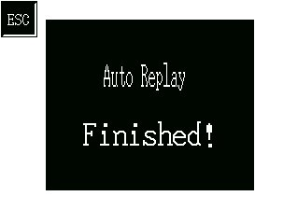
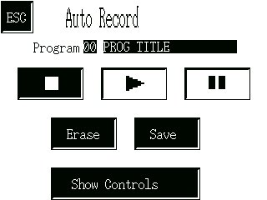

The program already selected will usually need to be eliminated by 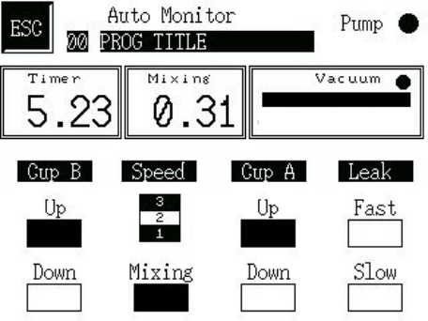touching the Erase button, which produces the confirmatory display of fig. 33.

The No, like the ESC button, returns control to the previous screen (fig. 33, page 20).

The Yes button also returns to the previous display, but the ‘auto record’ button now flashes, prompting the operator to initiate a recording sequence.

Fig. 33
WORKING PROCEDURES continued

AUTO RECORD (continued)

After confirming the start of recording by touching the flashing button, Show controls (flashing) displays the Auto recording screen (Fig. 34). From this screen it is possible to record From this screen it is possible to record the new sequence of actions, but not to change the data on the resin*.

Any button showing on this screen may be used, changing to black when active (the Up button for each cup opens in black, indicating the starting position). In the example of Fig. 34, the pump has been running for 1 min. 3 sec., not yet sufficient for evacuation (shown by the bar beneath Vacuum) to be complete.
Fig. 34

To record the program it is necessary only to operate the various controls at the appropriate moments. The actions taken are indicated by changes in the button colours, while times elapsed are all indicated automatically. The program steps have a resolution of one second: in other words, a one-second increase in program time must elapse before the next step begins (for example, a one-second delay must occur between changes of mixer speed).


A maximum of fifty program steps (00 to 49) is possible. At the last of these steps, the Memory Full warning display appears (Fig. 35). It is extremely unlikely that this condition will occur in normal practice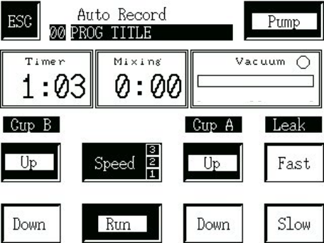.

The final steps of a sequence will be:
- Switch off the pump;
- Slow leak on;
- Fast leak on;
- Slow leak off;
- Fast leak off.

Fig. 35

After the last step has been entered, the ESC button is pressed to return control to the Auto record screen, on which the ‘stop’ button, seen to be flashing, must be touched to terminate the sequence. The program may now be deleted (e.g. if a mistake is believed to have been made) by touching Erase, when a new recording attempt may be carried out : or it may be accepted by selecting Save.

The ESC button now returns control to the Auto replay screen, from which the program may be replayed. Alternatively, the Menu screen may be selected where, if necessary, the resin data may now be changed*.

MANUAL CONTROL OF MACHINE
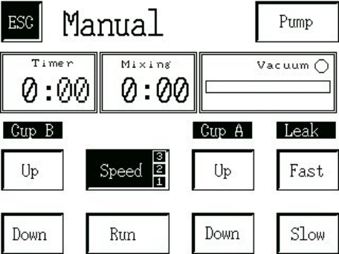
On touching the Manual button at the Menu screen, the Manual control display of Fig. 36 appears.

With the mould mounted and the resin components already weighed out into the cups, a sequence may be run under complete manual control from this screen. The resin type and weight do not need to be entered before beginning.

The operations are exactly as already described for Auto record, and must include the same final steps of the sequence.

When casting is complete, ESC returns control to the Menu screen.
Fig. 36

*see EDIT PROGRAM DATA (page 18)
WORKING PROCEDURES continued

SYSTEM DATA

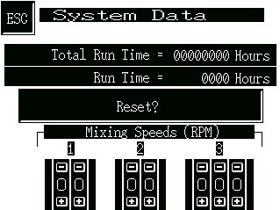
Selecting the System data display from the Menu screen reveals data relevant to maintaining the machine.

The Run time shown is re-settable. It should be set to zero when the pump oil is changed, and is then useful in determining the proper time for the next change. If the Reset button is selected, the Are you sure? screen (Fig. 37) appears.

The Total Run Time approximates the total operating time of the machine, which is in fact the length of time for which the vacuum pump has been operated. Since the machine will seldom be operated to any significant extend unless the chamber is under vacuum, this provides a reasonably good estimate.
Fig. 37

MIXER SPEEDS

The maximal values for the mixer speeds are the settings in place when the machine is delivered:

1 2 3
49 99 160 (r.p.m.)

The settings may be adjusted in the usual way to values appropriate to the task in hand, and when the Menu button is invoked the new current values will be recorded.

ALARMS

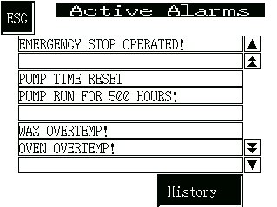
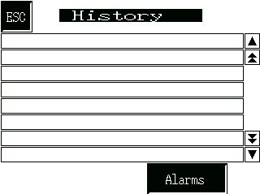
Malfunctions and program faults cause an alarm condition, which can be investigated by examining the Active alarms display (Fig. 38). Note that in certain conditions, this display may appear at start-up.

FAULT CONDITIONS
In the example shown, use of the emergency button has been automatically recorded. Other fault conditions, which may have occurred, are similarly recorded.

VACUUM PUMP
Fig. 38
It is recommended that the oil in the vacuum pump should be changed every 500 hours and among the fault conditions is a warning that the time limit has expired. When the limit has been exceeded, an attempt to operate the machine will cause the Active alarms display to appear with the message ‘Pump run 500 hours’. This does not prevent further use of the machine, but is a regular warning that the pump oil should now be changed which will recur until the Run Time has been re-set at the System data display.

HISTORY OF FAULTS
Touching the History button produces the display of Fig. 39, which lists the alarm conditions that have occurred, with the time and date (without the year) also indicated.

Fig. 39

APPENDIX

SYSTEM DATA

The screen displayed having pressed the TEMP button on the Menu screen will depend on the options included in your machine. If only the Heated Cup option is fitted, then the screen shown in Fig. 41 will be displayed, if the Heated Oven option is fitted then the screen in Fig. 43 will be displayed, if however, both options are fitted then the screen shown in Fig. 44 will be displayed.

Fig.40
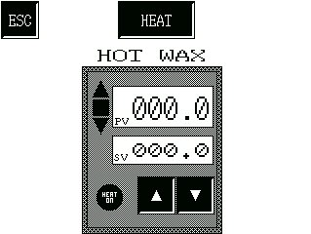
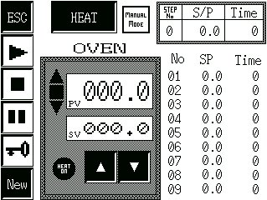
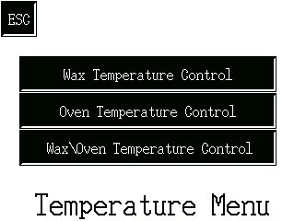
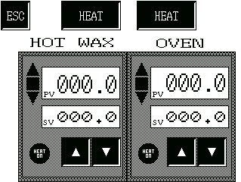
If both options are fitted then the screen shown to the right will be accessible from the Menu above. This screen allows the user to view and operate both temperature control loops concurrently.
Fig. 41
Fig.42
Fig.43

Fig.44

HOT WAX CONTROL

The screen shown in Fig.41 displays the control for the Hot Wax (Heated Cup) temperature. The current temperature of the cup is displayed in the upper window (PV) in centigrade and the lower window displays the set value (SV) also in centigrade.

The two buttons under these windows allow the user to raise or lower the set value. The value will scroll in either the up or downward direction as long as the button is pressed. The heater is turned on and off by the HEAT button at the top of the screen. The round lamp (HEAT ON) to the left of the raise/lower buttons indicates this.

Three further lamps to the left of the PV window indicate the direction of the actual temperature in relation to the SV, e.g. if the temperature is low, the down arrow will be lit.

APPENDIX continued

OVEN CONTROL

The screen shown in Fig.45 displays the control for the Oven temperature. The current temperature of the oven is displayed in the upper window (PV) in centigrade and the lower window displays the set value (SV) also in centigrade.

Manual Mode

The two buttons under these windows allow the user to raise or lower the set value. The value will scroll in either the up or downward direction as long as the button is pressed. The heater is turned on and off by the HEAT button at the top of the screen. The round lamp (HEAT ON) to the left of the raise/lower buttons indicates this.
Fig.45

Three further lamps to the left of the PV window indicate the direction of the actual temperature in relation to the SV, e.g. if the temperature is low, the down arrow will be lit, when the temperature is at the set point the centre square lamp will be lit.

Automatic Mode

However, this screen allows the user to define a temperature profile which the oven will follow for up to nine steps. This gives the user a greatly enhanced control over the oven temperature over time. This profile can then be saved and re-used as required. The set up and use of the profile feature is described below.

Entering Profile Elements

The display shows the current values for each step on the right of the screen. These values are edited using a ‘pop-up’ keypad. The keypad is activated by use of the ‘Key’ button on the lower left of the screen. Values are then entered on the keypad. The current value being edited will have a flashing box around it. When the desired value has been entered, pressing the Enter key will accept the value and move the box (cursor) onto the next value. The order in which they are edited are as shown on the screen, i.e. Temperature set point then time.

It should be noted that not every step has to be used. If a step is not required, then simply enter zeros for both temperature and time. Also, should a temperature be entered but the time entered as zero, the step will not be used and will simply move onto the next step.

Once the profile has been edited the ‘Hide’ button closes the keypad.

Running a Profile

Once a profile has been edited and the keypad closed, the user can then run the new profile. This is done using the standard PLAY button (Right Arrow). Once the PLAY button has been pressed, the oven temperature will follow the profile. The current step, set point and time can be seen in the top right of the screen. Whilst running the PLAY button will flash.

At any time during playback the user can pause the profile by pressing the PAUSE button. This will hold the profile in its current state until the PAUSE button is pressed a second time. Whilst in Pause mode, the button will flash.

The profile will end when all 9 steps have been completed. Alternatively, the STOP button can be pressed at any time to stop the profile and reset it. When PLAY is pressed again, the profile will start from the beginning.

APPENDIX continued

Saving a Profile

When a profile has been edited and checked to be correct, the user can save the current profile for use again. This is done using the NEW button. This takes the user to another screen asking if they wish to save or not. Pressing YES saves the profile details to memory and takes the user back to the previous screen. Pressing NO takes the user back to the previous screen without saving.

Pressing the ESC button takes the user back to the Heated Cup/Oven Menu screen.

ROUTINE MAINTENANCE PROCEDURES

Apart from keeping the unit in a generally clean condition, routine maintenance of the Vacuum Casting Machine is concerned with the vacuum pump and its associated filters. Users are referred to the Service Manual for other repair or replacement procedures.

* Before carrying out any operation on the vacuum pump or its filters, allow the equipment to stand idle for at least one hour.

* Never use any oil but the correct grade as recommended.

* Check the oil level regularly. The optimal frequency depends greatly on usage and should be set after observation at short intervals (e.g. daily or weekly) during the first periods of use.

OIL CHANGES

The first oil change for a new pump should be made after 150 hours of operation.

The period between subsequent changes may be varied to match actual usage. Assuming a full working week of forty hours, MCP Equipment suggest that the oil be changed at intervals of three months, corresponding to 520 hours (refer to the maintenance schedule in the pump manufacturer’s manual in case of any doubt). Longer periods allow the build-up of sludge and other deleterious matter, which may shorten the life of the pump by causing excessive wear.

A copy of the pump manufacturer’s manual is supplied with the casting machine. For the user’s convenience, the following instructions summarise the procedure for maintenance of the pump, but the manual itself should be consulted for explicit instructions for changes of oil and/or filter as well as other cleaning operations.

- Remove the oil filler cap from the top of the pump

- Open the drain tap at the bottom left of the pump, and allow it to drain (through a hose) into a suitable receptacle.

- When the oil-flow appears to have ceased, operate the pump for no more than thirty seconds with the vacuum chamber doors open.

- Close the drain tap and put in one litre of fresh, clean vacuum pump oil. Replace the filler plug.

- Close the vacuum chamber doors and operate the pump for three or four minutes, to flush out residual deposits.

- Repeat operations 1, 2 and 3.

- Close the drain tap and refill the pump with fresh, clean oil to the gauge on the sight window. Replace the oil filler cap.

Operating the machine in very humid conditions can cause moisture to be drawn into the vacuum pump, where it will form a layer of water at the bottom of the sump and cause the level to rise about the gauge line. If you notice this effect (which is most easily discernible after a period of non-use, such as over a night), drain off the layer through the drain tape to bring the oil down to its correct level.

DECLARATION OF CONFORMITY

Manufacturer’s name and address: MCP EQUIPMENT
(A DIVISION OF MINING & CHEMICAL PRODUCTS LTD.)
UNIT 8, WHITEBRIDGE INDUSTRIAL ESTATE,
STONE
STAFFORDSHIRE ST15 8LQ

Equipment type and designation: Vacuum Casting Machine
Type MCP 4/06 and variants

Serial Number: …………………………………………………

Directives/Regulations to which
the equipment conforms: 1. Council Directive 89/392/EEC and its amending directives, leading in the United Kingdom to The Supply of Machinery (Safety) Regulations (SI 1992 No. 3073) (as they apply to equipment with a moving part and intended for treating or moving material.

2.Council Directive 89/336/EEC and its amending directives, leading in the United Kingdom to The Electromagnetic Compatibility Regulations (SI 1992 No. 2372).

3. Council Directive 73/23/EEC and its amending directives, leading in the United Kingdom to The Low Voltage Electrical Equipment (Safety) Regulations (SI 1989 No. 728).

Safety standard to which the
equipment uses: BS 2771 : Part 1, as applicable to the electrical and electronic equipment
of machines not portable by hand when working, used in industrial production and operated from a supply up to 1000 V a.c. (equivalent to European standard EN 60 204). The equipment also complies with the essential Health and Safety requirements.

Person responsible for
Technical File: Simon Scott,
Manager for Technical Data – MCP Equipment Division

